#DontStopTheMusic

Check out the latest artists set to deliver live performances to your home

Wedemark/Germany, April 6, 2020 – Sennheiser’s #DontStopTheMusic series continues with Alexander Knappe (who joins the already announced Sublime with Rome on Tuesday), Alysha, Spencer Barnett, Emily Laing, LEW, Split the Dealer, Claud, MACKandgold, Hektor Mass, DJ Lord Issa and Chris Scholar. A big thank you to the artists and their teams!

Live concert streams from Tuesday, April 7 to Tuesday, April 14
Please follow @sennheiser on Instagram and switch on notifications in IGTV to receive alerts, as dates and artists may be subject to change at short notice.
- Alexander Knappe (@alexanderknappe):
Tuesday, April 7 at 17:00 UTC (13:00 New York time (EDT), 19:00 Berlin time, CEST), please see note on time zones below)
- Alysha (@alisha_gr):
Wednesday, April 8 at 18:00 UTC (14:00 New York time, 20:00 Berlin time)
- Spencer Barnett (@spencerbarnett):
Wednesday, April 8 at 19:00 UTC (15:00 New York time, 21:00 Berlin time)
- Emily Laing (@emily_laing_uk):
Thursday, April 9 at 19:00 UTC (15:00 New York time, 21:00 Berlin time)
- LEW (@lewloh):
Friday, April 10 at 14:00 UTC (10:00 New York time, 16:00 Berlin time)
- Split the Dealer (@splitthedealer):
Friday, April 10 at 19:00 UTC (15:00 New York time, 21:00 Berlin time)
- Claud (@claud.mp3):
Saturday, April 11 at 19:00 UTC (15:00 New York time, 21:00 Berlin time)
- MACKandgold (@mackandgold)
Sunday, April 12 at 19:00 UTC (15:00 New York time, 21:00 Berlin time)
- Hektor Mass (@hektormass ):
Monday, April 13 at 19:00 UTC (15:00 New York time, 21:00 Berlin time)
- DJ Lord Issa (@djlordissa)
Monday, April 13 at 20:00 UTC (16:00 New York time, 22:00 Berlin time)
- Chris Scholar (@chrisscholar):
Tuesday, April 14 at 19:00 UTC (15:00 New York time, 21:00 Berlin time)

* A note on the time zones
The concert times are given in Coordinated Universal Time (UTC), with EDT and CEST added for convenience. EDT is short for Eastern Daylight Time, which is four hours behind Coordinated Universal Time. EDT is the time in New York, for example. CEST is Central European Summer Time, which is two hours ahead of UTC – Berlin or Wedemark time, for example.

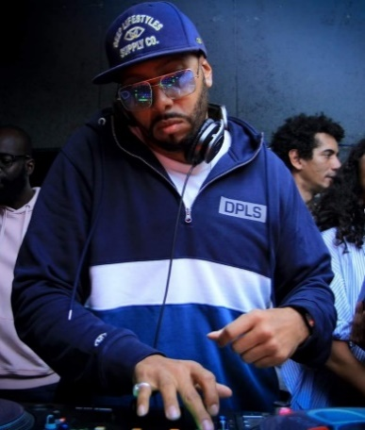
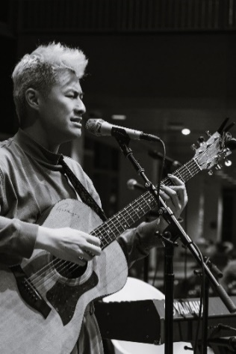

More music
Please also check out http://www.sennheiser.com/anniversary for the next livestream dates and a great selection of music videos to watch and listen to. Just put on your headphones (or turn up the speakers) and immerse yourself in immersive jazz club recordings, electro sets, or live takes from recording studios.

It’s free but why not donate to fight the coronavirus?
At Sennheiser, we’re delighted to be working with these fantastic artists to help spread positivity by putting on exclusive concerts. They’re totally free, but if you do want to say thank you, do consider supporting the WHO in its fight against the coronavirus:
https://www.who.int/emergencies/diseases/novel-coronavirus-2019/donate

For your social media channels:
Enjoy your favorite artists at home and check out the exclusive concerts in Sennheiser’s (@sennheiser) streaming concert series – live on Instagram! #DontStopTheMusic

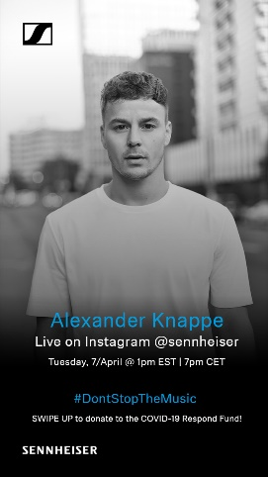 | 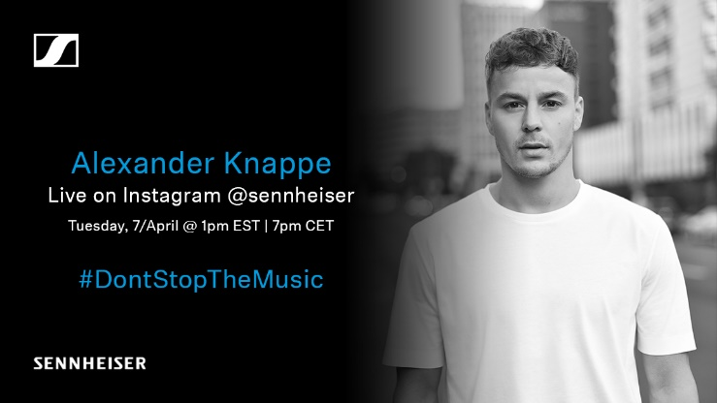
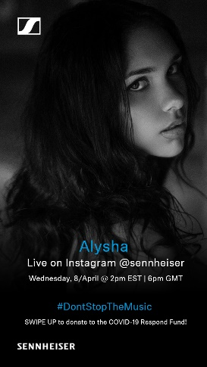 | 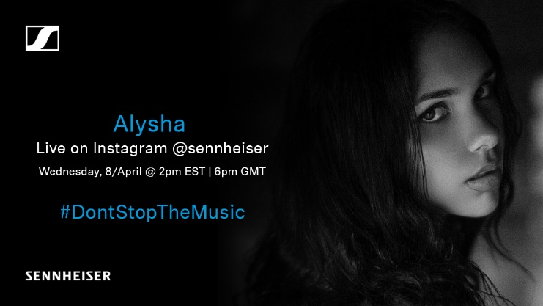
 | 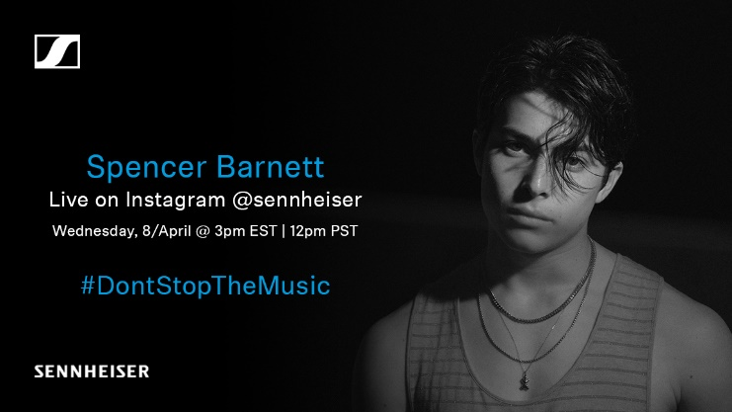
 | 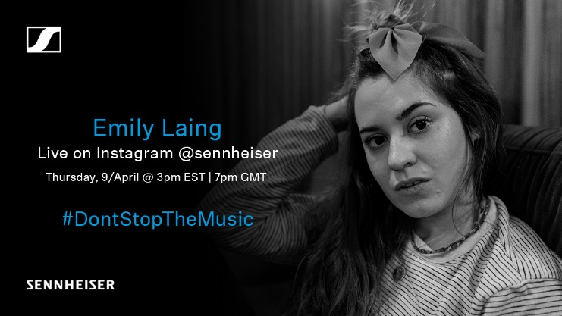
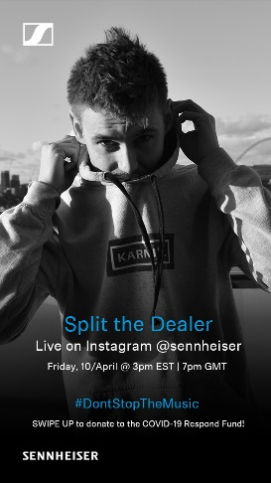 | 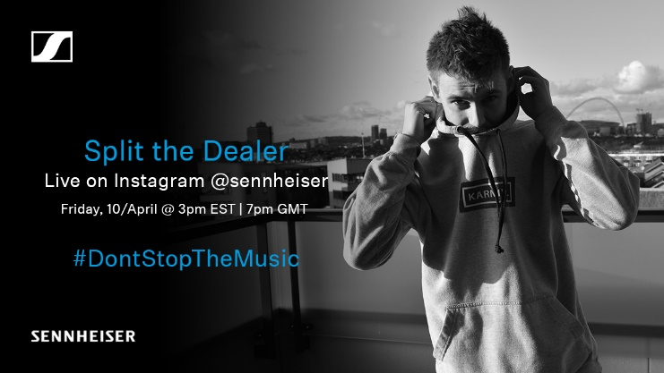

The artist images accompanying this press release can be accessed here: https://sennheiser-brandzone.com/c/181/ifCTr9Yu.

About Sennheiser
Founded in 1945, Sennheiser is celebrating its 75th anniversary this year. Shaping the future of audio and creating unique sound experiences for customers – this aim unites Sennheiser employees and partners worldwide. The independent family company, which is managed in the third generation by Dr. Andreas Sennheiser and Daniel Sennheiser, is today one of the world’s leading manufacturers of headphones, loudspeakers, microphones and wireless transmission systems. In 2018, the Sennheiser Group generated turnover totaling €710.7 million. www.sennheiser.com

Press Contacts

Mareike Oer Stephanie Schmidt
mareike.oer@sennheiser.com stephanie.schmidt@sennheiser.com
T +49 0(5130) 600 – 1719 T +49 0(5130) 600 – 1275

